A
Industrial Training/Seminar Report
On
SMART HOME LIGHT AUTOMATION
Submitted
In partial fulfillment
For the award of the Degree of
Bachelor of Technology
in Department of Computer Science and Engineering


Department of Computer Science and Engineering
Rajasthan College of Engineering for Women
Rajasthan Technical University
Session 2025-2026

CANDIDATE’S DECLARATION

I hereby declare that the work presented in this Seminar Report entitled “Smart Home Light Automation System” is my own work carried out under the guidance of _Harveer sir.
This report has not been submitted anywhere for any other degree.

Submitted By:
Anita 23ERWCS008
Aaska 23ERWCS001
Astuti 23ERWCS014
Arshika 23ERWCS013
Palak 23ERWCS063
Rajni 23ERWCS068
Bimla 23ERWCS017
Akshita Chaudhary 23ERWCS003
Department of Computer Science & Engineering
Rajasthan College of Engineering for Women, Jaipur

CERTIFICATE
This is to certify that the Seminar/Project Report titled “Smart Home Light Automation System” submitted by complete group of smart home light automation is a genuine work completed under harveer sir guidance.
To the best of my knowledge, the work has not been submitted earlier for any degree.

Project Guide: _Harveer sir_________
Assistant Professor
Department of Computer Science and Engineering
RCEW, Jaipur

ACKNOWLEDGEMENT

We would like to express our sincere gratitude to our guide harveer sir______ for their guidance and support throughout the project.
We also thank our HOD radhav sir, Director arihant khincha, and our respected faculty members for providing continuous support.

We are grateful to our college Rajasthan College of Engineering for Women for giving us the opportunity to work on this project.
Lastly, we thank our team members, friends, and family for their constant encouragement.

Team Members:
Anita, Aaska, Astuti, Arshika, Palak, Rajani, Bimla, Akshita Chaudhary
.

TABLE OF CONTENTS

Candidate’s Declaration ..................................................... ii
Certificate .............................................................................. iii
Acknowledgement .............................................................. iv
Abstract .................................................................................... 1

CHAPTER 1: INTRODUCTION

1.1 Introduction ............................................................................. 2
1.2 Overview of Smart Home Automation ................................ 3
1.3 Problem Statement .................................................................. 4
1.4 Motivation ................................................................................ 4
1.5 Objectives ................................................................................ 5
1.6 Contribution of Project ......................................................... 5

CHAPTER 2: LITERATURE REVIEW

2.1 Introduction ............................................................................. 7
2.2 Related Work .......................................................................... 7
2.3 Conclusion ............................................................................... 9

CHAPTER 3: PROPOSED METHODOLOGY

3.1 Introduction ............................................................................. 10
3.2 System Components .............................................................. 10
3.3 Working of the System ......................................................... 12
3.4 System Architecture/Block Diagram .................................. 13
3.5 Evaluation Parameters ........................................................... 15

CHAPTER 4: RESULTS & ANALYSIS

4.1 Introduction ............................................................................. 16
4.2 System Output ........................................................................ 16
4.3 Performance Analysis ............................................................ 17

CHAPTER 5: CONCLUSION & FUTURE WORK

5.1 Conclusion ............................................................................... 19
5.2 Future Enhancements ............................................................ 20

References ................................................................................ 21

ABSTRACT

The Smart Home Light Automation System allows users to switch lights ON and OFF using a mobile web application. The system uses an Arduino microcontroller connected to a relay module, which controls the home lights. The web app sends commands to the Arduino through Wi-Fi, enabling users to operate the lights from anywhere inside the home.
The main aim of the project is to reduce manual effort and make home lighting more convenient and user-friendly. This system demonstrates a simple and cost-effective approach to home automation using IoT technology.

---

CHAPTER 1 – INTRODUCTION

1.1 Introduction

Home automation provides users control of household appliances through the internet.
In this project, we built a system where lights can be controlled using a phone’s web application.
The user can press ON/OFF buttons on the web interface, and the Arduino switches the light accordingly using a relay.

1.2 Overview of the System

The system consists of:
A web application with ON and OFF buttons.
An Arduino/NodeMCU connected to Wi-Fi.
A relay module connected to the light.

When the user presses ON/OFF on the phone, the Arduino receives the command and turns the light ON or OFF.

1.3 Problem Statement

Traditional switching requires the user to physically reach the switchboard every time. This is inconvenient, especially at night, for elderly people, or when switches are far.

1.4 Motivation

To make home lighting easier, more convenient, and accessible through a phone.

1.5 Objectives

To control home lights using a phone web application.

To provide ON/OFF control from anywhere in the Wi-Fi range.

To build a simple and low-cost IoT solution.

1.6 Contribution

Our project successfully shows how everyday home functions like lighting can be automated using Arduino and a simple web interface.

---

CHAPTER 2 – LITERATURE REVIEW

2.1 Introduction

IoT-based home automation has gained popularity due to its simplicity and usefulness.

2.2 Related Work

Past studies used:
Bluetooth modules
Sensors
Voice assistants
Advanced home automation kits

Our system focuses on simple web-based control using Arduino, making it affordable and easy to implement.

2.3 Conclusion

Existing systems prove the success of IoT in automation. Our project follows the same concept with simplified implementation.

---

CHAPTER 3 – PROPOSED METHODOLOGY

3.1 System Components

Arduino / NodeMCU (ESP8266 or ESP32)

Wi-Fi Module (built-in)

Relay Module

Mobile Web App

Light Bulb / Lamp

Power Supply

3.2 Working of the System

1. The phone connects to the same Wi-Fi network as the Arduino.

2. The web app is opened in the browser.

3. The user presses ON → command sent → Arduino → Relay turns light ON.

4. The user presses OFF → Arduino switches relay OFF → Light turns OFF.

3.3 System Architecture (Explain)

Phone Web App → Wi-Fi → Arduino/NodeMCU → Relay → Light
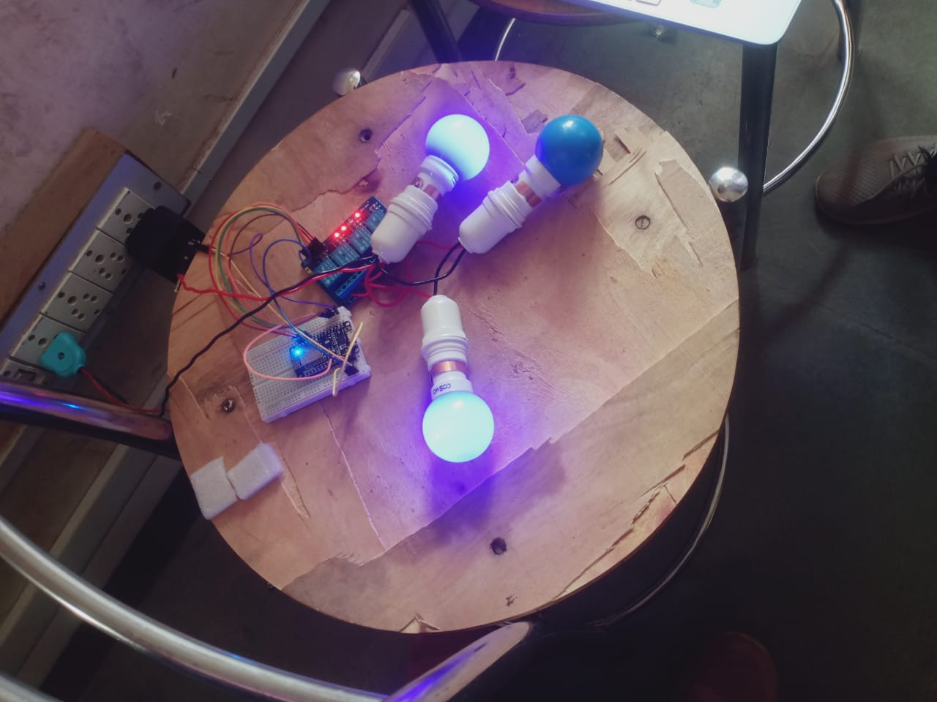

3.4 Advantages

Very easy to use

Works on any mobile phone

Low cost

No extra sensors

Reliable switching

3.5 Evaluation Parameters

Response time

Network performance

Relay switching accuracy

---

CHAPTER 4 – RESULTS & ANALYSIS

4.1 Introduction

Testing was done inside a home using a Wi-Fi router.

4.2 Results

Light turned ON/OFF instantly after pressing the button.

Web app responded within 1–2 seconds.

System worked smoothly within Wi-Fi range.

4.3 Performance Analysis

Accuracy: 100% switching success

User Experience: Simple and interactive

Power Consumption: Very low

---

CHAPTER 5 – CONCLUSION & FUTURE WORK

5.1 Conclusion

The Smart Home Light Automation System successfully allows users to control lights from a mobile phone’s web application.
The system is cost-effective, easy to build, and highly reliable for home use.

5.2 Future Enhancements

Add voice control (Alexa/Google)

Add mobile app instead of web app

Add more appliances (fan, AC, TV)

Add scheduling (automatic ON at night)

